**STEP: 1 Create Maven Project**

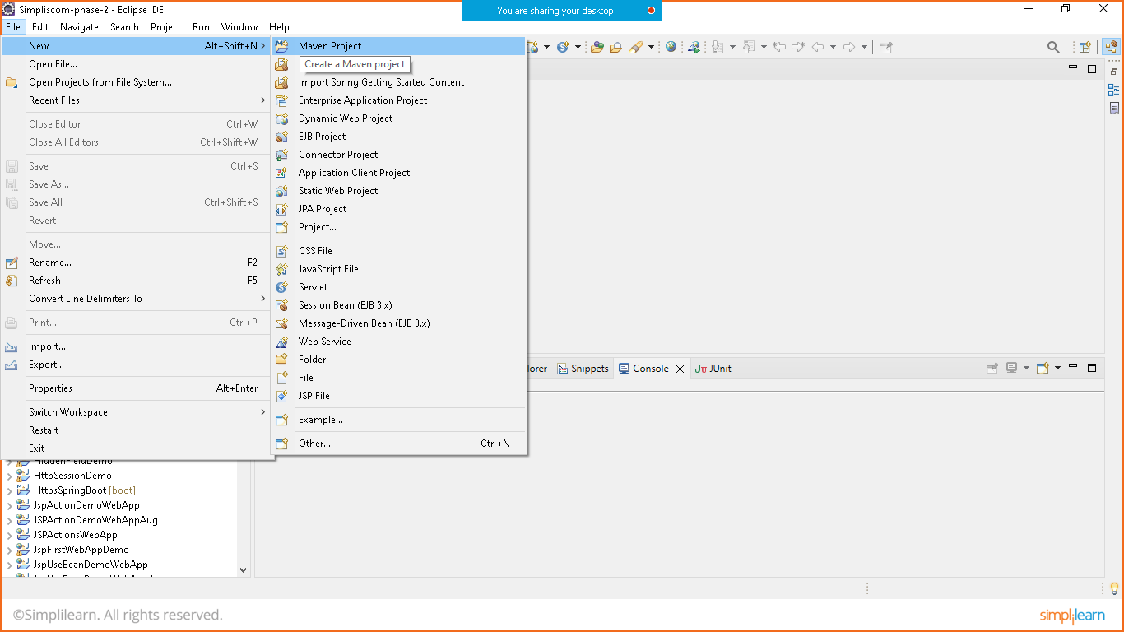

Click on next

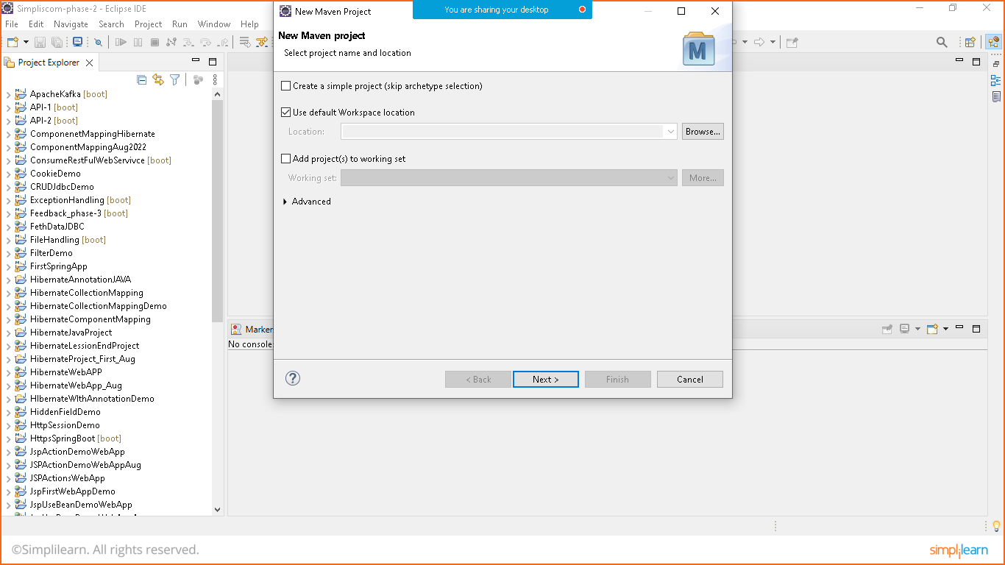

Choose webapp

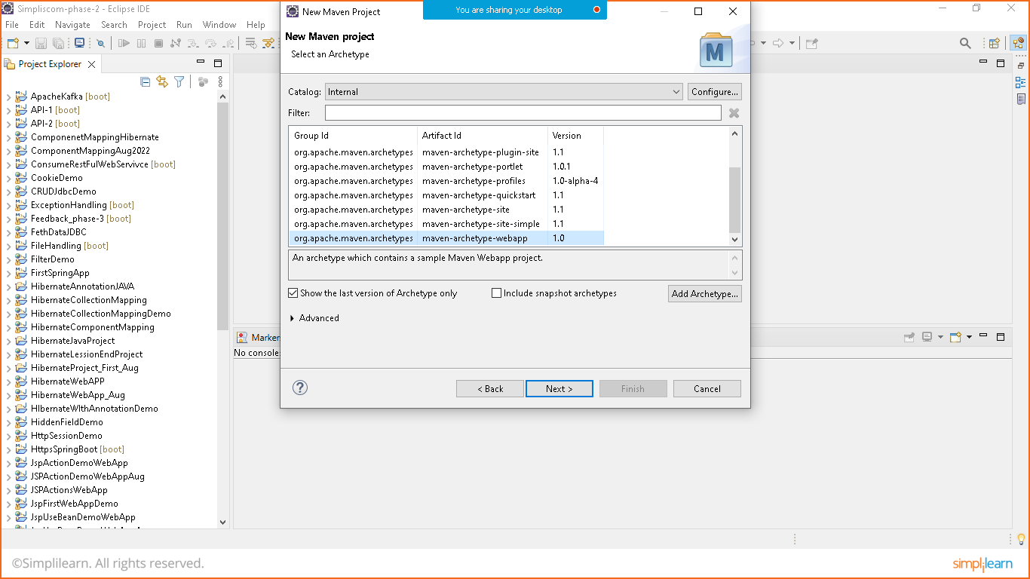

Group id and package id is same

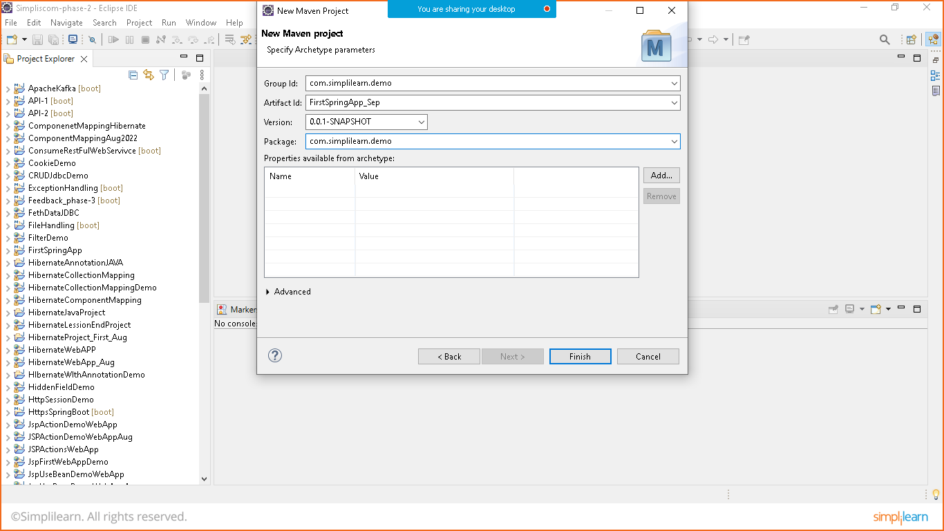

Click on finish

**STEP:2 REMOVE MAVEN-WAR- PLUGIN ERROR**

For that gotot> google and search for maven war plugin and maven compiler plugin in **pom.xml** file

<project xmlns="http://maven.apache.org/POM/4.0.0" xmlns:xsi="http://www.w3.org/2001/XMLSchema-instance"

xsi:schemaLocation="http://maven.apache.org/POM/4.0.0 http://maven.apache.org/maven-v4_0_0.xsd">

<modelVersion>4.0.0</modelVersion>

<groupId>com.simplilearn.demo</groupId>

<artifactId>FirstSpringApp_Sep</artifactId>

<packaging>war</packaging>

<version>0.0.1-SNAPSHOT</version>

<name>FirstSpringApp_Sep Maven Webapp</name>

<url>http://maven.apache.org</url>

<dependencies>

<dependency>

<groupId>junit</groupId>

<artifactId>junit</artifactId>

<version>3.8.1</version>

<scope>test</scope>

</dependency>

</dependencies>

<build>

<finalName>FirstSpringApp_Sep</finalName>

<!--To remove error add below code-->

<plugins>

<plugin>

<groupId>org.apache.maven.plugins</groupId>

<artifactId>maven-war-plugin</artifactId>

<version>3.3.1</version>

</plugin>

<plugin>

<groupId>org.apache.maven.plugins</groupId>

<artifactId>maven-compiler-plugin</artifactId>

<version>3.10.1</version>

</plugin>

</plugins>

<!--Maven Code ends here-->

</build>

</project>

STEP:3 ADD dependencies for spring

<!--Spring core-->

<dependency>

<groupId>org.springframework</groupId>

<artifactId>spring-core</artifactId>

<version>5.3.22</version>

</dependency>

<!--Spring Expression-->

<dependency>

<groupId>org.springframework</groupId>

<artifactId>spring-expression</artifactId>

<version>5.3.22</version>

</dependency>

<!--Spring Beans-->

<dependency>

<groupId>org.springframework</groupId>

<artifactId>spring-beans</artifactId>

<version>5.3.22</version>

</dependency>

<!--Spring Context-->

<dependency>

<groupId>org.springframework</groupId>

<artifactId>spring-context</artifactId>

<version>5.3.22</version>

</dependency>

<!--Spring context Support-->

<dependency>

<groupId>org.springframework</groupId>

<artifactId>spring-context-support</artifactId>

<version>5.3.22</version>

</dependency>

<!--Spring ORM-->

<dependency>

<groupId>org.springframework</groupId>

<artifactId>spring-orm</artifactId>

<version>5.3.22</version>

</dependency>

<!--Spring Web-->

<dependency>

<groupId>org.springframework</groupId>

<artifactId>spring-web</artifactId>

<version>5.3.22</version>

</dependency>

<!--Spring web MVC-->

<dependency>

<groupId>org.springframework</groupId>

<artifactId>spring-webmvc</artifactId>

<version>5.3.22</version>

</dependency>

<!--JAVA Servlet API-->

<dependency>

<groupId>javax.servlet</groupId>

<artifactId>javax.servlet-api</artifactId>

<version>4.0.1</version>

<scope>provided</scope>

</dependency>

Now update maven project

